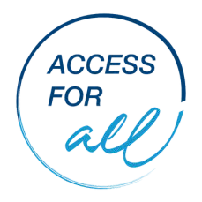
Summary of Accessibility Changes Identified After Using the ‘Access for All - Accessibility Checklist’

 | Access Barrier Identified  From Accessibility Check List | Corrective Action | Person/People responsible | Action Date | Notes
Building Access
Practice Access
Disability Awareness

 | Access Barrier Identified  From Accessibility Check List | Corrective Action | Person/People responsible | Notes | Action Date
Communication, Contacting Service/Practice and Making Appointments
All staff Clinical, reception,
administration, management
Other Accessibility Accommodations to Make

Funded by the Australian Government Department of Social Services.

