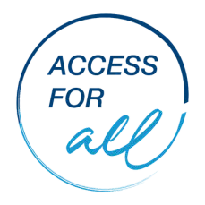
Accessibility Improvement Action Plan
NB: Develop one ‘Accessibility Improvement Action Plan’
for each accessibility issue identified with the ‘Access for All - Accessibility Checklist’.

;
Accessibility Issue Description:
- Building Access  - Practice Access  - Disability Awareness  - Communication, Contacting and Making Appointments  - Staff Related  - Accessibility Accommodations |  | Detailed description of accessibility issue:
Desired Outcome:
Strategic Action | People Responsible |  | Resources Required | Stakeholders | Notes | Date to be completed by
All strategic actions to be completed by (date):

Funded by the Australian Government Department of Social Services.

